Q.1 Java program to print welcome message.

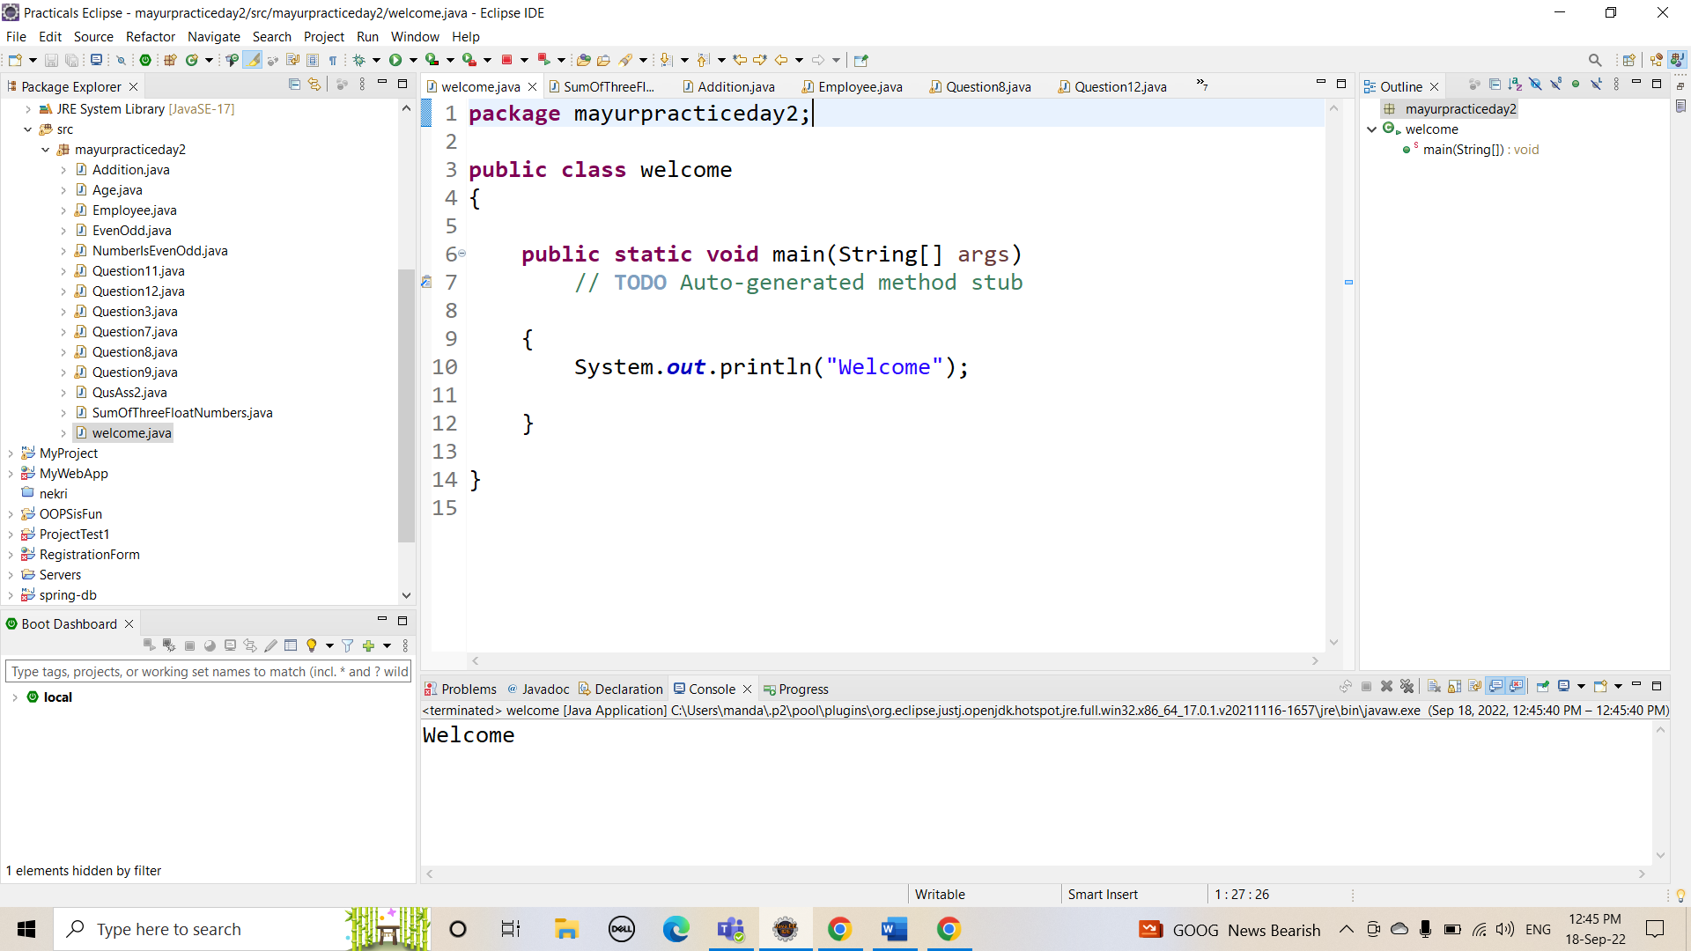

Q.2 Java program to print sum of  three float numbers.

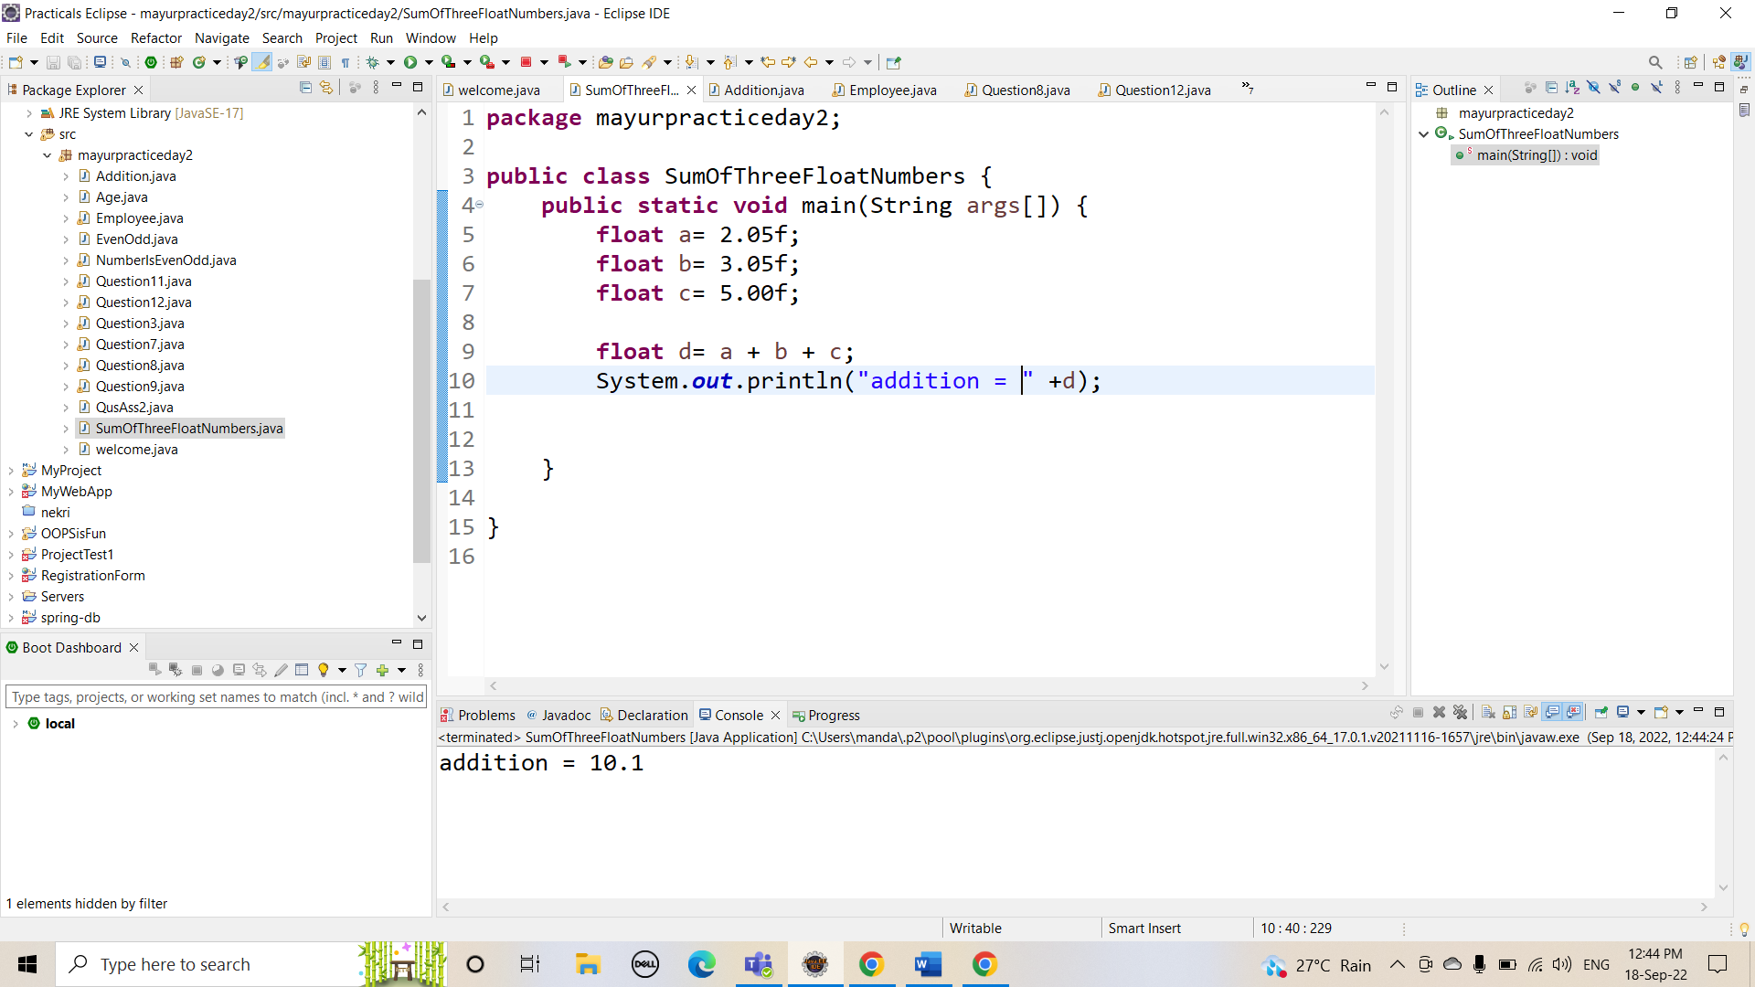

Q 3 Java Program to Swap Two Numbers

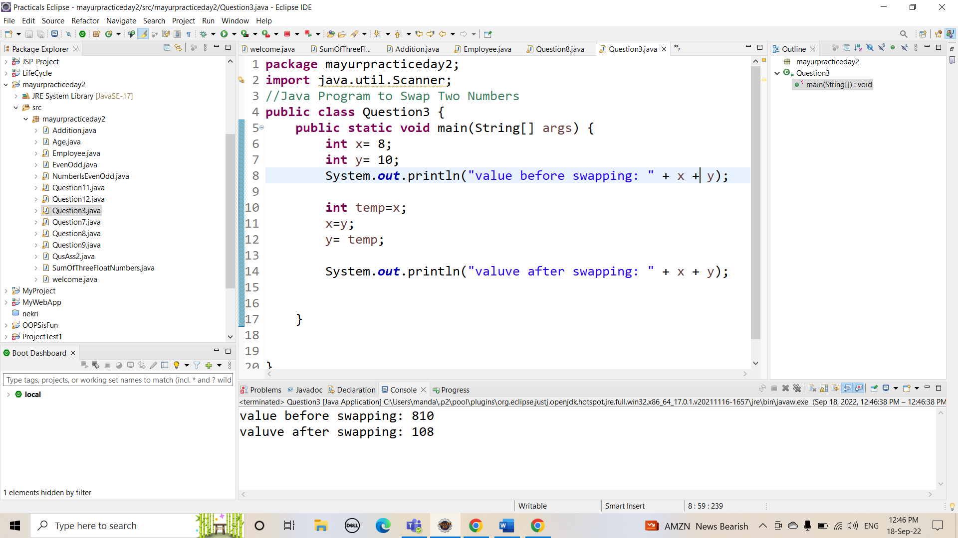

Q 4 Wap to check if number is even or odd

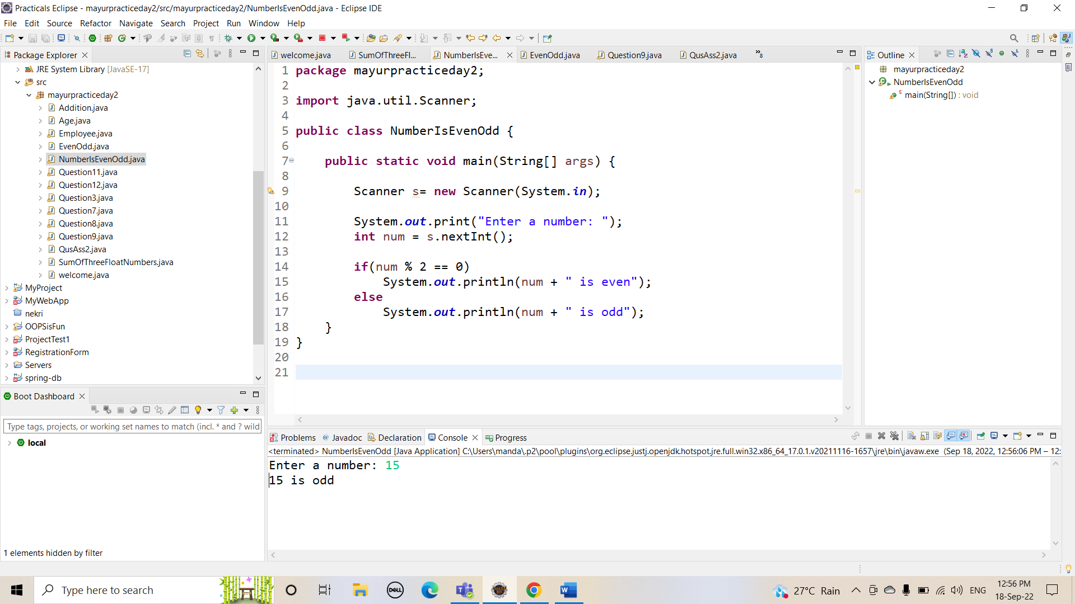

Q.5 wap to check from three given number that whether a number is greater than or equal to 20 and less than other numbers .print appropriate message.

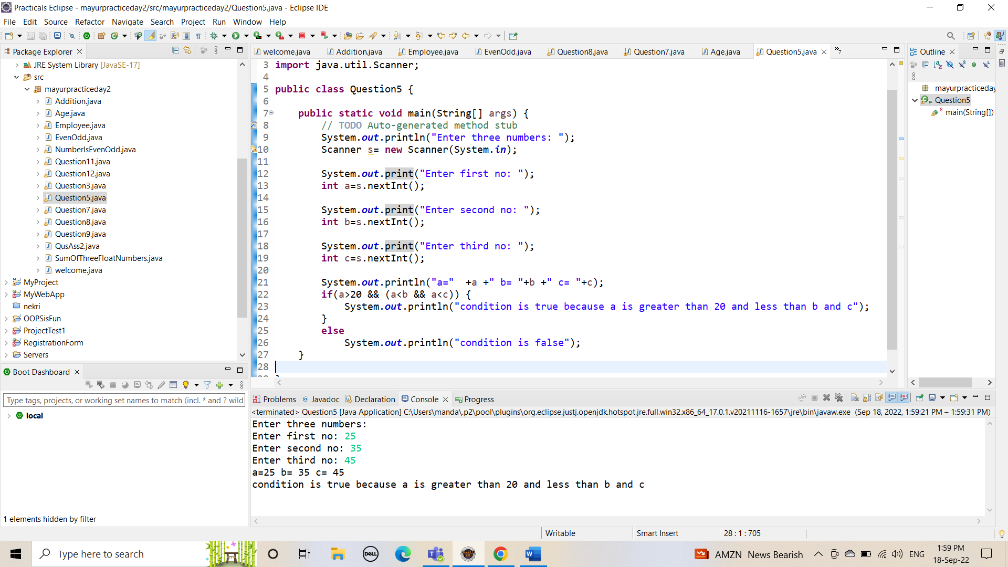

Q.7 wap to check if sales of a person is greater than 10000 then eligible for bonus   
else not eligible calculate bonus as 20% of sales .

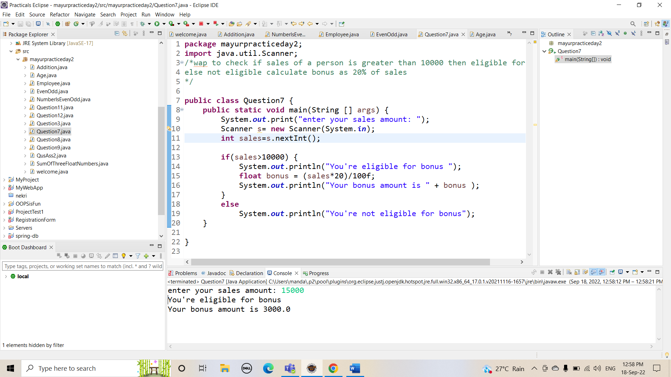

Q.8 wap to check if two given integer value is in range of 18 and 100 print eligible for voting else not eligible .

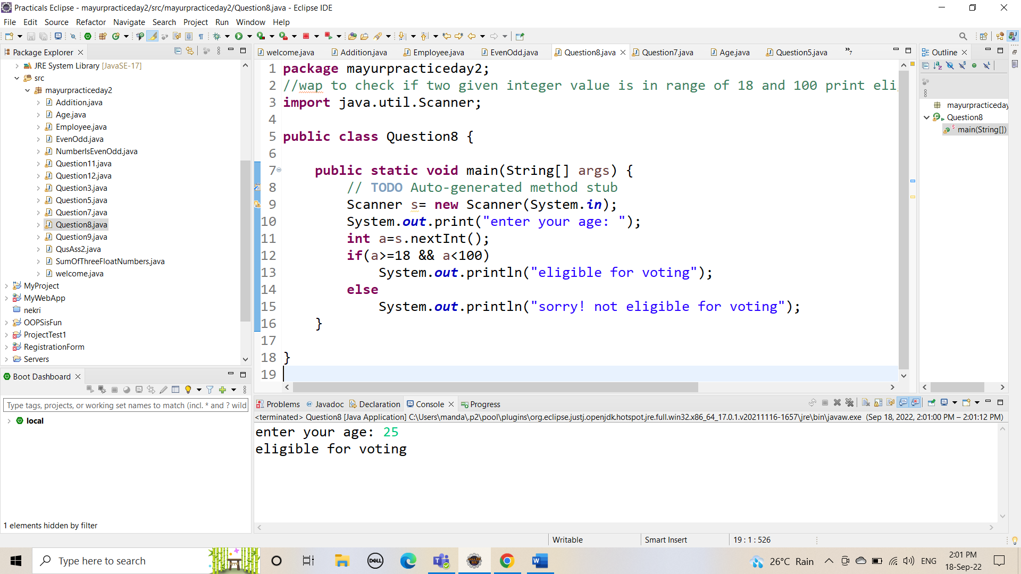

Q.9  wap to print average of  given five subjects marks of student and check if average >=40 print Pass else print fail

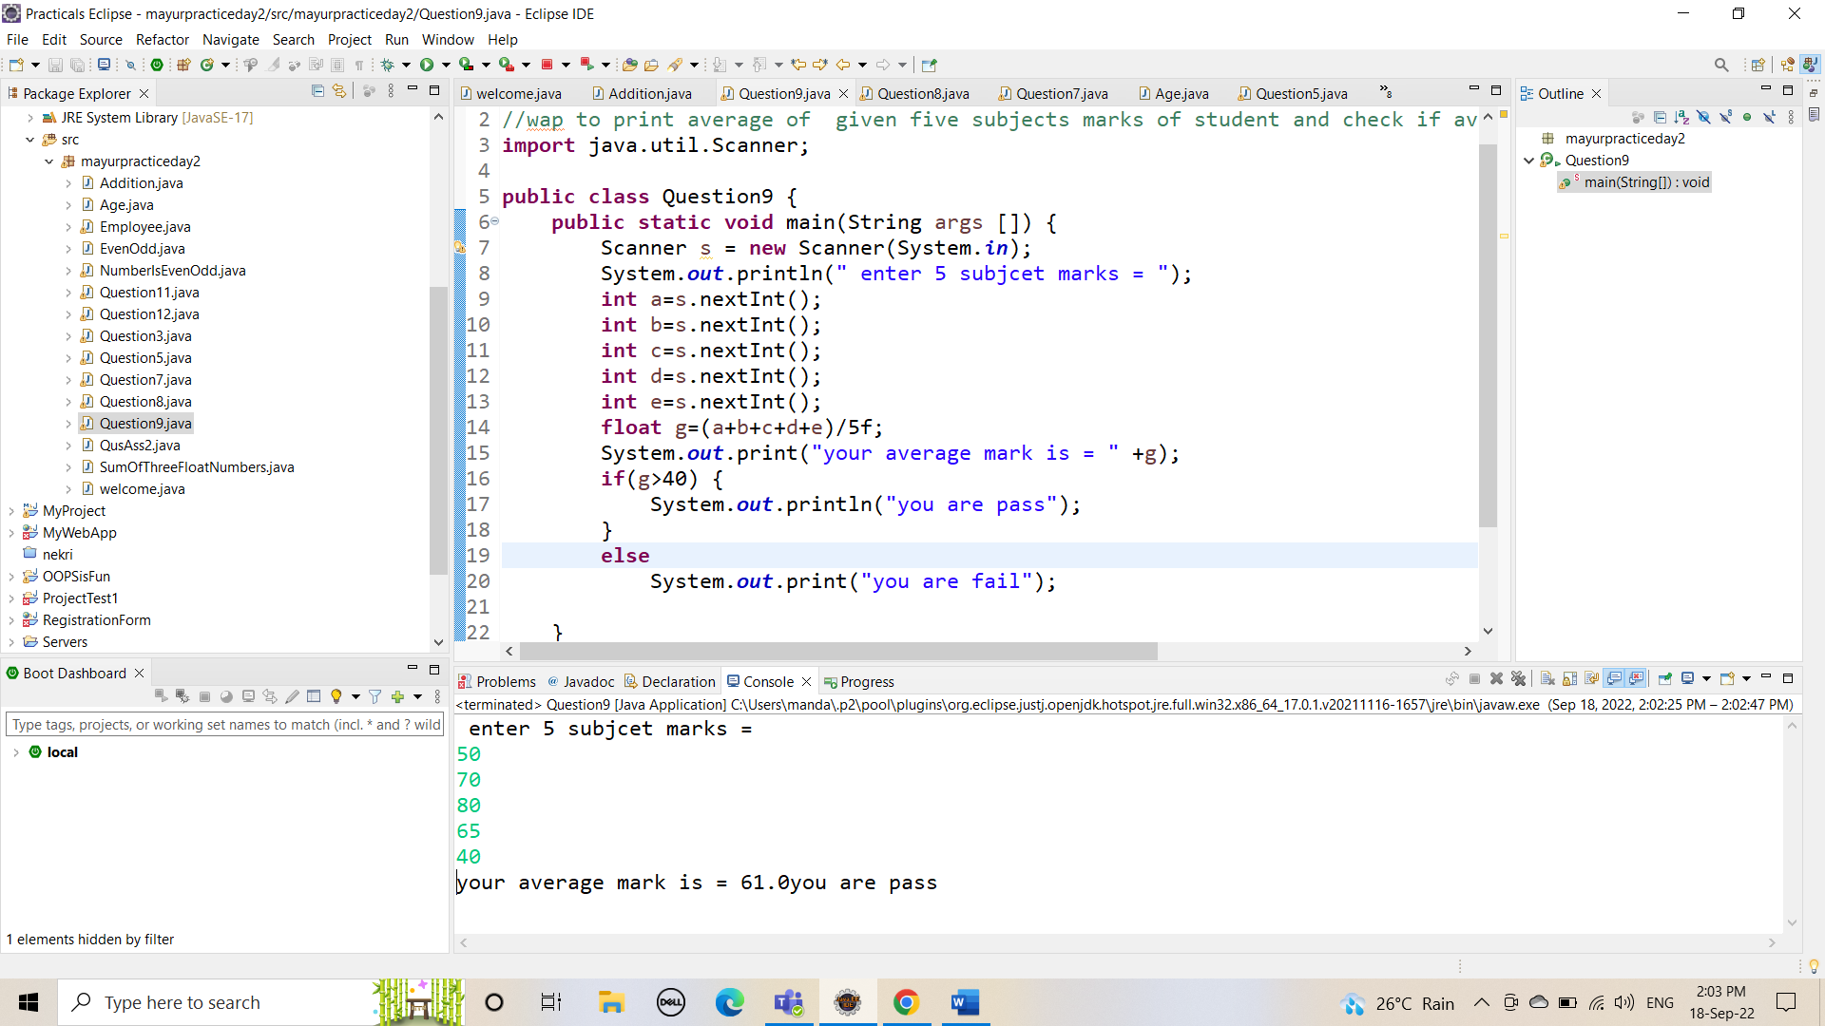

Q10 WAP to ask name ,age and salary of an employee and print on console.

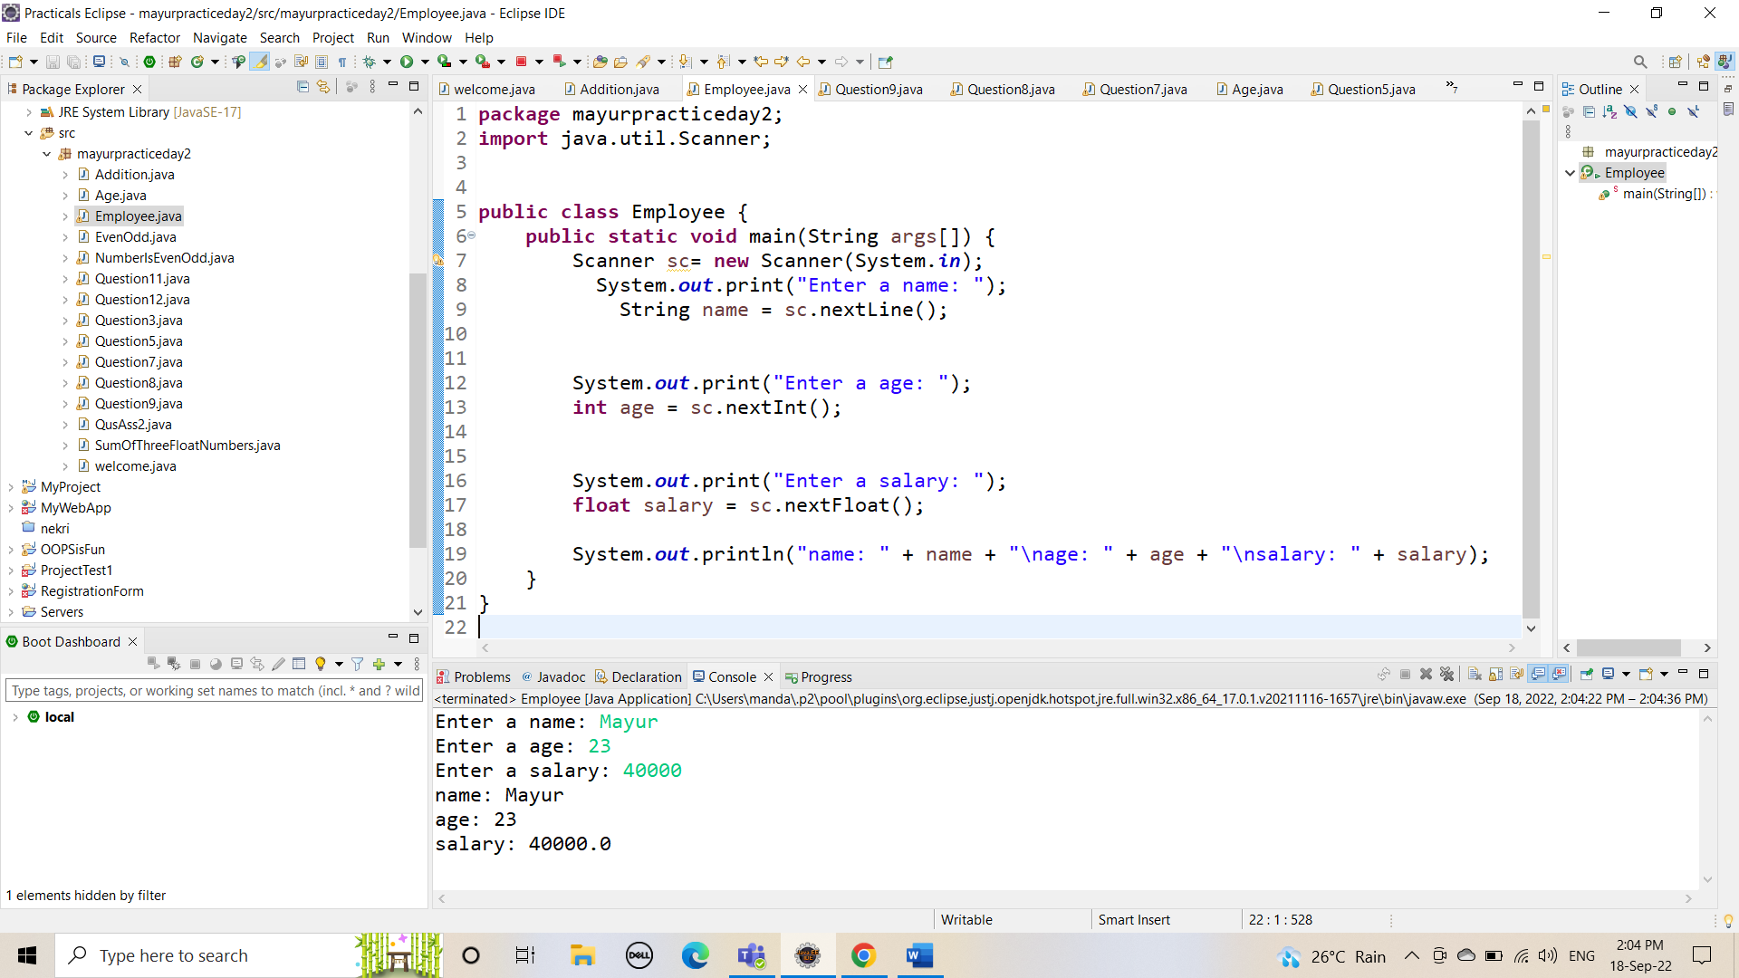

Q 11 wap  that ask two numbers from user and print greater number among two

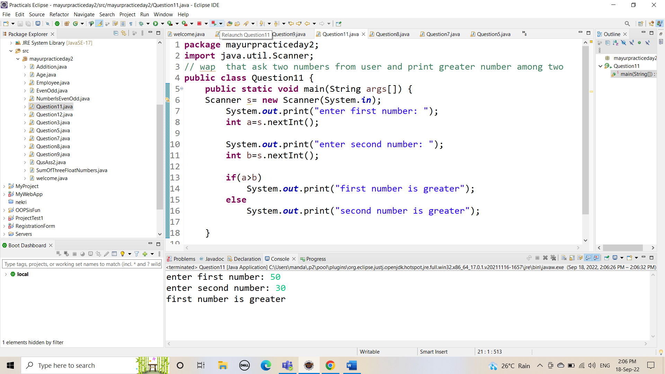

Q 12  wap to ask product name and price of product from user and calculate discount i.e   
if price > 2000 then discount is 10 percent of price   
else discount is 7 % of price

